|  |  |
| --- | --- |
|  | |
|  |
|  |

SAVE GIRL

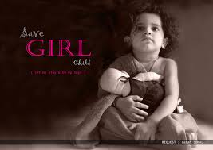  
ATTENTION PLEASE:

KFKF-------BEING A HUMAN NOT AN ANIMAL!!

---------------SAVE A GIRL TO SAVE TOMMOROW!!

WHEN

YOU

KILL A GIRL KILL MANY OTHERS  
